**The secret geometry of Florence: a scientific tour of the renaissance city**

[**SIMONE SANNIO**](http://www.italoamericano.org/author/simone+sannio) | SEP 11, 2017

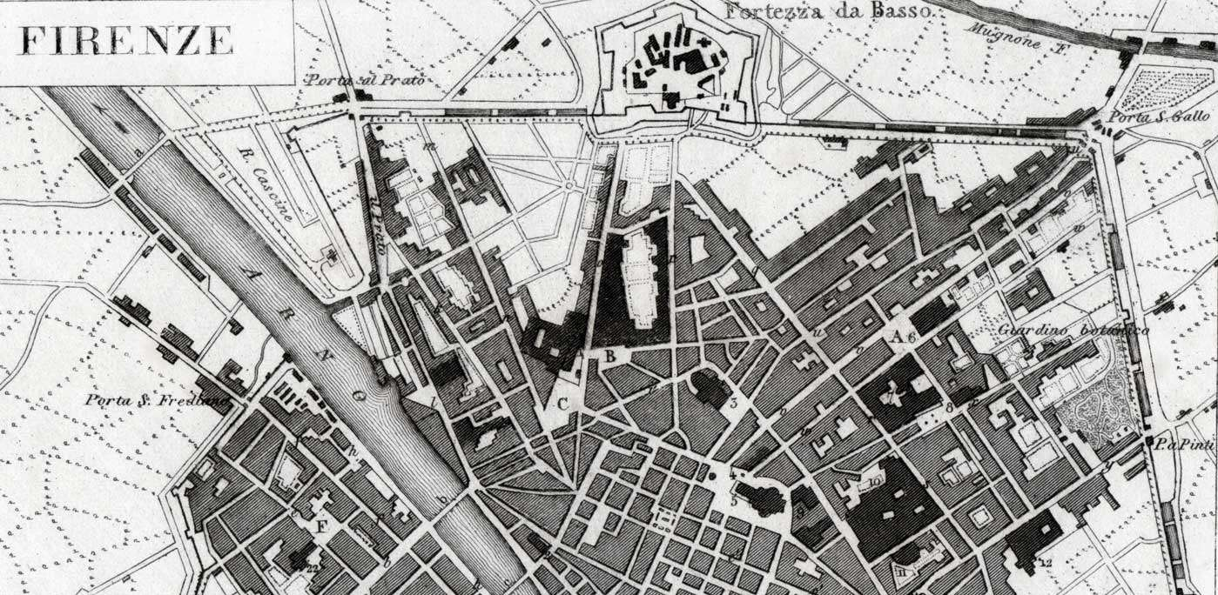

Geometry is visible everywhere in Florence, one just needs to pay attention

Michelangelo, Raffaello, Leonardo... and then again Leonardo, Galileo, and many more famed artists and scientists: there is no doubt that Firenze – the Renaissance City – has been for centuries the real keystone of both Western art and modern science. In fact, it appears that some of the leading figures of the city’s art scene were also very well-versed in subjects as diverse as geometry, mathematics, astronomy, and anatomy, among others. In spite of this well-known fact, though, the intersection between architecture and mathematical proportions which plays such a crucial role in making Florence’s churches and palaces look so perfect is still often overlooked. Let’s take a walk through the “city of art and science,”  stop in front of its main sights and look more closely at their façades in search of Firenze’s sacred geometry: a “secret geometry” as well, after all.

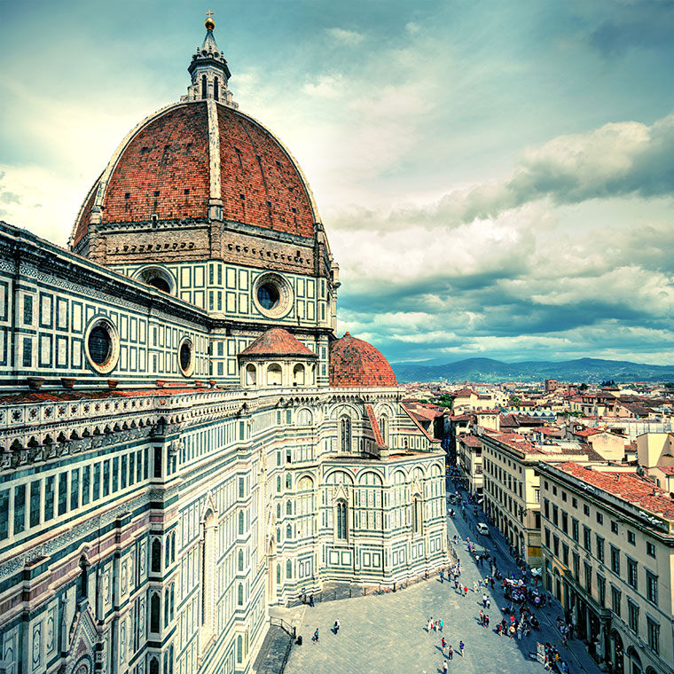The unique buildings that make up the complex of Santa Maria del Fiore are there for all to see, only a small part of the millions of people that every year visit these monuments, taking pictures and selfies and sending postcards all over the world actually seems to notice

Our “scientific tour” of the city’s historic center cannot but begin in the Piazza del Duomo main square. We could almost say that everything we really need to know about the geometry of Florence stands right here in front of us, under everyone’s eyes, in one of the most visited places in the whole planet. Although the secrets of the unique buildings that make up the complex of Santa Maria del Fiore are there for all to see,  only a small part of the millions of people that every year visit these monuments, taking pictures and selfies and sending postcards all over the world actually seems to notice.

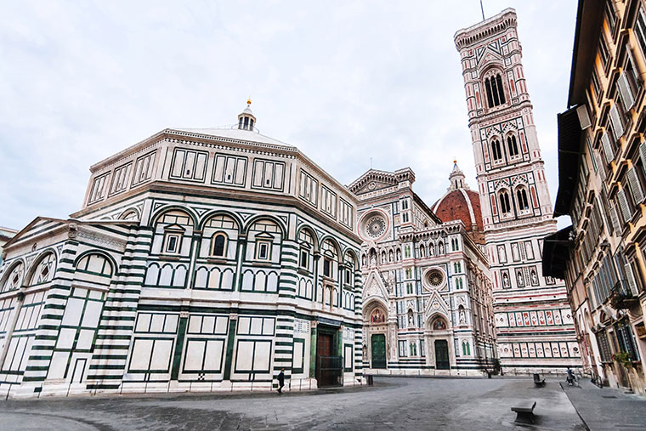The Battistero di San Giovanni is a perfect example of  geometry at work in Florentine architecture

Take, for example, the Battistero di San Giovanni (Baptistery of Saint John), the oldest building in the square: a single glance cannot possibly help us figure out just how complex, awe-inspiring, and perfect this monument is. Of course, it is easy to detect its octagon-shaped design, shared by other similar religious buildings: but what about each of its eight sides? Every single one of them is divided horizontally into three sections, in turn split vertically into just as many parts: the upper section, in particular, is made up of three small windows included in a three-part pattern, while the middle one has three blind arches, each including a bigger window.

This tangle of geometrical shapes might seem complicated enough as it is: but again, what about the carefully planned alternation of white Carrara marble and green Prato marble? And what about the sequence of the bronze door panels by masters Lorenzo Ghiberti and Andrea Pisano, to say nothing of the building’s interiors? Sure enough, the Baptistery’s ground-breaking commingling of art and science does not end there: apart from the awesomeness of the triangular ceiling mosaics under the dome, San Giovanni also hides within it an unexpected tribute to astronomy engraved on the marble floor, namely a solstice sundial representing the signs of the Zodiac.

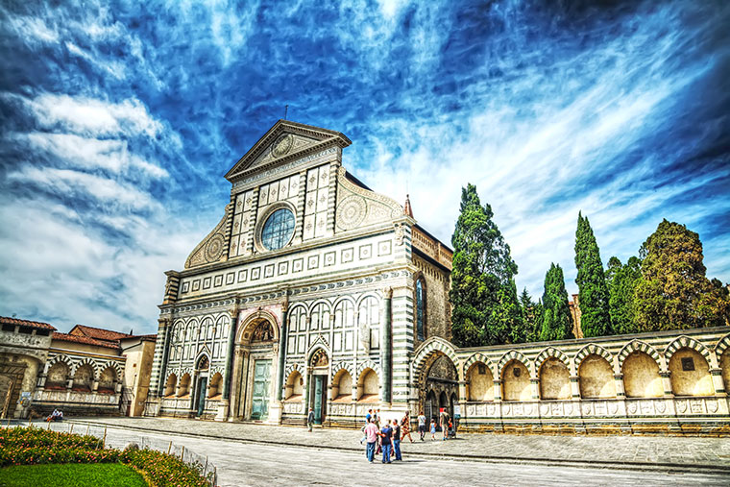The lively façade of Santa Maria Novella

All things considered, it is no surprise that during the Renaissance the Battistero became the most revered building in the city, thus having a huge influence on the construction and the adornment of the near bell tower and cathedral. Most inspired by it was probably the great architect Filippo Brunelleschi, who managed to discover linear perspective – carrying out a real Copernican revolution in Western art – by carefully studying the shape and symmetry of the octagonal Florence Baptistery. Just a few years later, Brunelleschi capitalized on his own findings by realizing the impressive brick dome of the Basilica di Santa Maria del Fiore, an unsurpassed masterpiece: as it appears, the external structure is not simply circular as one would expect, but rather octagon-shaped – just like that of the Battistero – and sustained by some “ribs,” so as to better withstand its own weight through geometric proportions.

But there is a lot more maths hidden in Brunelleschi’s dome: according to expert opinion, for instance, the size of the dome itself was based on nothing less than the golden ratio, the so-called “divine proportion,” if not on the Fibonacci sequence. As for the other sciences honored on the cathedral’s façade, we notice a bust of Galileo on the bottom left corner of the central rose window, as well as a series of geometrical panels with allegorical representations of the “Liberal Arts” on Giotto’s campanile: among them, architecture, sculpture, and painting are coupled with arithmetic, geometry, and astronomy.

Ultimately what emerges from our exploration of the Piazza del Duomo is that during the Renaissance the fields of art and science were not as neatly separated as they are today. Just think that another great architect and mathematician of that golden era, Leon Battista Alberti, stated – at the end of his famous treatise On Painting – that “no painter could paint well who did not know much geometry.” But there is another particular reason why mathematics so greatly influenced the aesthetic and technical choices of the masters of the past: observance of the laws of geometry, resulting in balance and grace, allowed the Renaissance artists to pursue divine perfection, so that man could get closer to God. It is exactly the same lesson we learn from Leonardo da Vinci’s drawing of the Vitruvian Man: a human figure inscribed in a circle and a square, representing Heaven and Earth respectively – the perfect symbol of the symmetry of man and nature, but also the ultimate, intimate union of art and science.

It would probably take an entire lifetime to discover all the secret patterns that lie hidden beneath the surface of Florence’s monuments and palaces. Our walk could include, for example, a visit to the armillary sphere and gnomon on the lively façade of Santa Maria Novella – one of Alberti’s greatest masterpieces – or else the admirable interlocking of geometric shapes in San Lorenzo’s Old Sacristy and Santa Croce’s Pazzi Chapel, both by Brunelleschi. An itinerary seeking to show the close link between Florentine art and science, however, can hardly ignore the collection of the Museo Galileo (the former Institute and Museum for the History of Science) or the Museo FirST – Firenze Scienza e Tecnica (Florence Museum of Science and Technology). The latter, in particular, occasionally organizes – in cooperation with the University of Florence’s math department – a series of passeggiate matematiche: “mathematical walks” through the city led by specialists and researchers who have really devoted their life to the study of Renaissance architectural forms’ secrets.